Master Programme in International Relations, a.y. 2022/2023
Course on History and International Relations of the Middle East
Centro dipartimentale di studi storici e politici sull’Africa e il Medio oriente

Wednesday, 9th of November, 2022, 13-15hrs CET

Aula 1, Palazzo Hercolani, Strada Maggiore 45, 40125 Bologna

Lecture

The Political Economy of the Financial Crisis in Lebanon
and its Implications for Arab countries

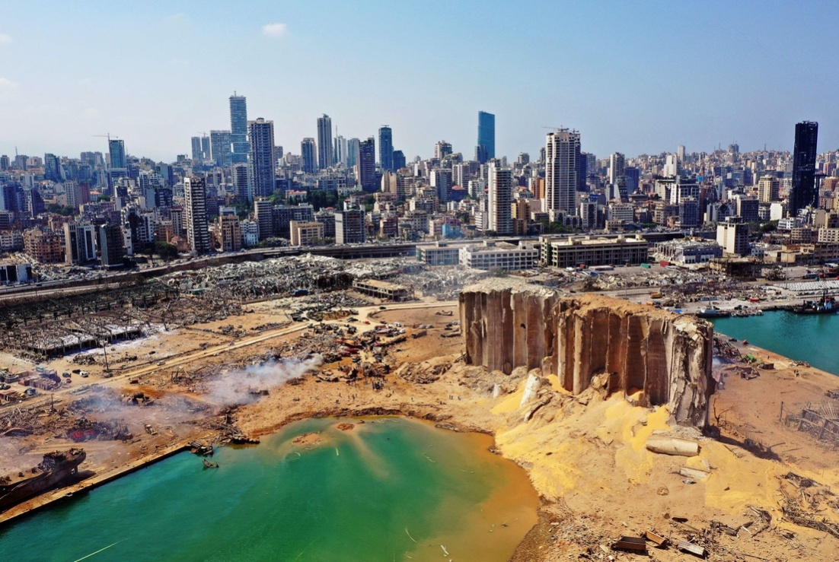

by dr. Samir Aita

Cercle des economistesarabes
UN Consultant for Economy, Finance, Labour and Urban Planning in West Asia

The crisis that emerged in Lebanon in 2019 is one of the most severe in contemporary history. The lecture aims at understanding its origins and unfolding, the impact on social movements and “reform” efforts, not least for other Arab countries as well.

Chair: Massimiliano Trentin, University of Bologna
Discussant: Francesco Saverio Leopardi, University of Bologna

Link MSTeams

